6 Zone Voice Evacuation Controler
EN-6500 (500W)
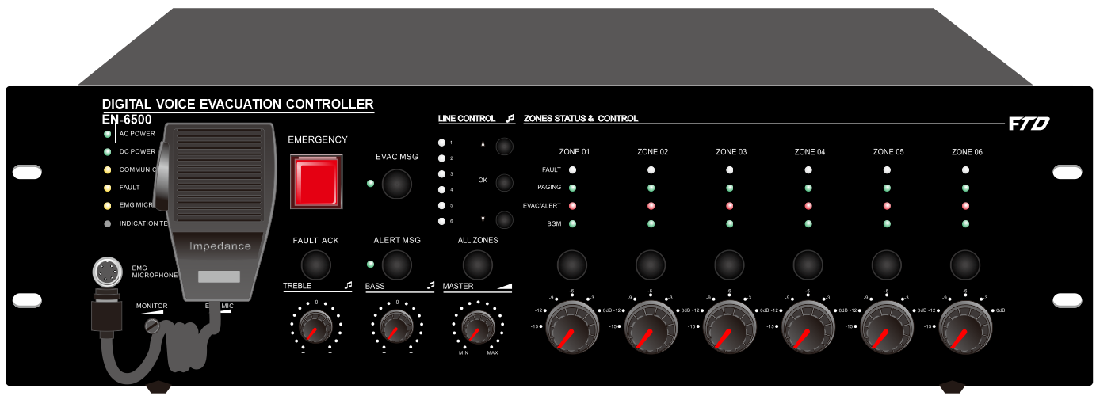
Features:
- Digital voice evacuation system all in one amplifier.
- Specifications meet the standards of BS EN54-32 & EN608409.
- EN54-16 standards certificate is under taken.
- Built-in 500W 6 zone class-D amplifier.
- Integration of EVAC controller, paging system, PA system & BGM system together.
- Built-in two separate players for EVAC and alert voice message by SD card.
- Built-in 6 zone AB speaker line low impedance supervision.
- Built-in amplifier auto changeover into standby when fault.
- With external amplifier input to expansion the power.
- Capacity of connection 32 units remote microphones.
- Red button EVAC message push to activate with priority except fireman microphone.
- 6 zone speaker outputs with separate zone volume control (ATT).
- 6 zone separate indicator for EVAC, fault, music/paging & select.
- System indicators of AC, DC, fault and indicators for EVAC, alert & fireman microphone.
- Zone capacity of 120 zones by cascaded 19 routers.
- With 8 programmable control inputs and 8 programmable control outputs for voice evacuation system.
- With Fault, EVAC outputs and Reset input for third party system integration.
- With fireman microphone of highest priority.
- Priority level: fireman mic, EVAC, input 1, remote microphone, timer & BGM.
- Two combo inputs for mic/line, 4 line inputs and one REC output.
- Two RJ45 ports for router, two RJ45 for remote microphone input and two RJ45 for LAN/WAN/Internet network.
- IP network module for optional to buy.
- AC 230V and DC24V battery input. Auto switch into the battery backup when AC fails.

Rear Panel:
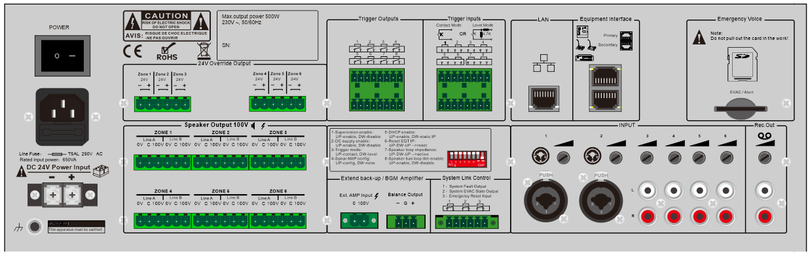

6 Zone Voice Evacuation Controler
EN-6500 (500W)

Specifications:
Model | EN-6500
Description | 6 Zone Voice Evacuation Amplifier
Rated Power Output | 500W
Fireman Microphone | 5Mv, 600Ω
Line 1-2 Inputs | 385mV, 10kΩbalanced Combo
Line 3-6 Inputs | 350mV, 10kΩ, RCA
Frequency Response | 80Hz~20kHz
THD | ＜1% at RMS,1KHz
S/N Ratio | >70dB
Speaker Output | 100V AB 8 zone speaker outputs
REC Output | 200mV
Control Input & Output | 8 programmable control inputs: Max 3.3V (voltage mode) or 0V closed contact  8 programmable control outputs: 0V closed contact; Control output for fault & EVAC: 0V closed contact; Reset control input: 0V closed contact
Voice Message | MP3 or WMA format, two separate players of SD card with protection cover, programmable voice message up to 255, 10 years valid
Event Record | HEX format, Hard Flash memory, events up to 1000 records, 10 years valid
Operation Environment | Operation Temp: +5℃ ~ +40℃; Store Temp: -20℃ ~ +70℃; Operation Humidity: <95%
Power Consumption | 600W
Power Supply | AC230V or 115V & DC24V battery inputs, 50-60HZ
AC Fuse | 250V/6.3A, slow type and restorable fuse
Dimension | 484(W)×132(H)×449(D) mm
Weight | 24kg
System Connection Diagram:
